2.2 Equation of Lines
Straight lines, which are the simplest graphs, play an important role in a wide variety of applications. They are considered here from both a geometric and an algebraic point of view.
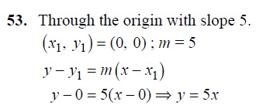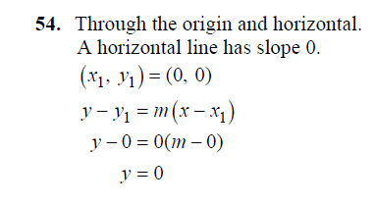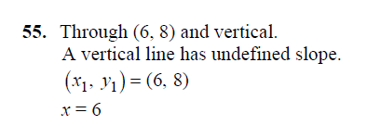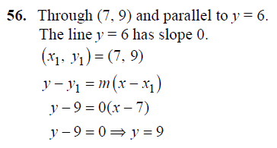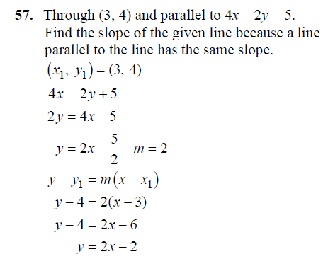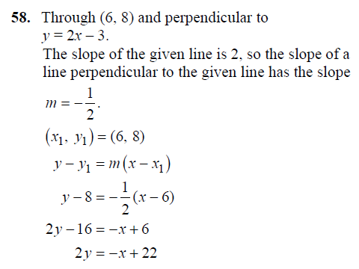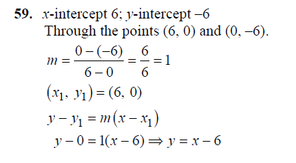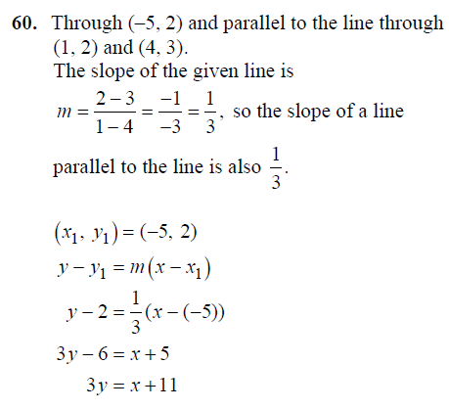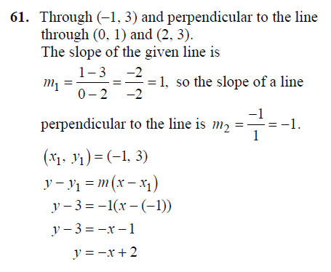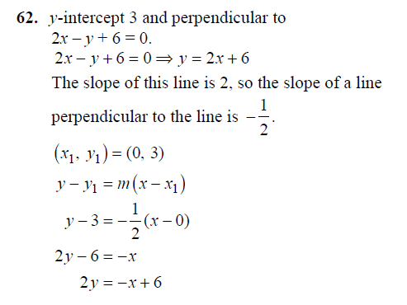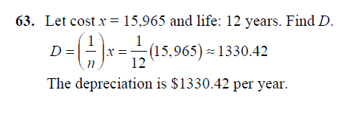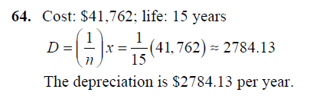
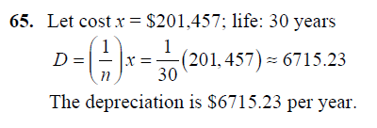
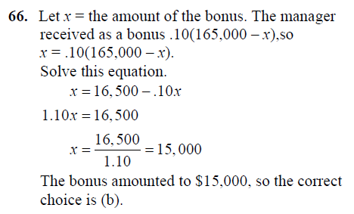
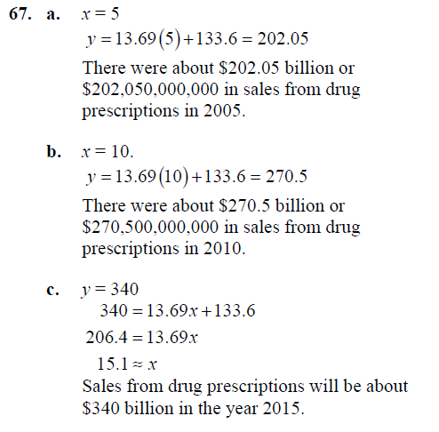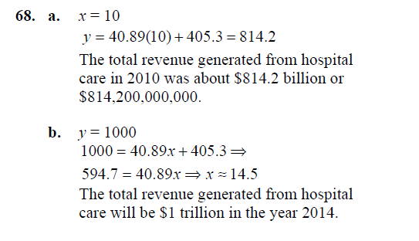

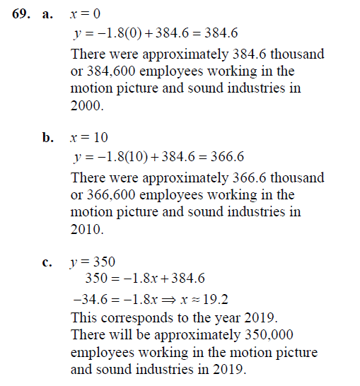
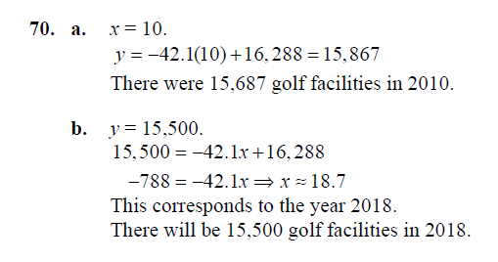
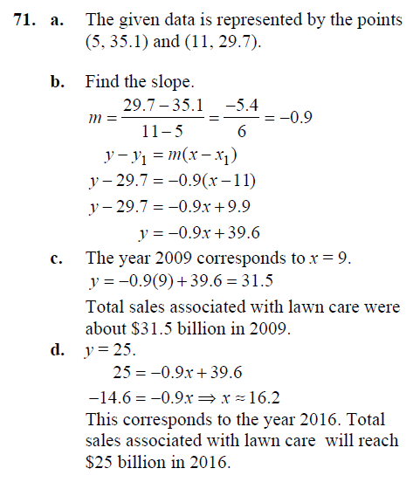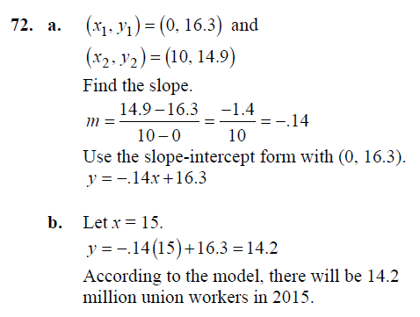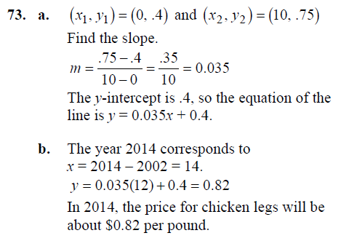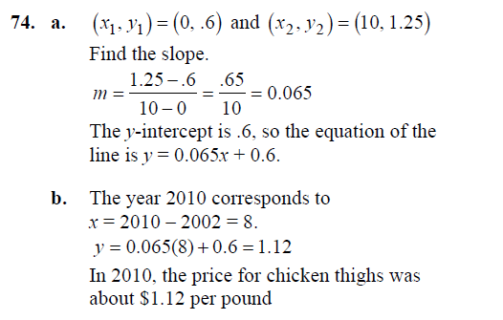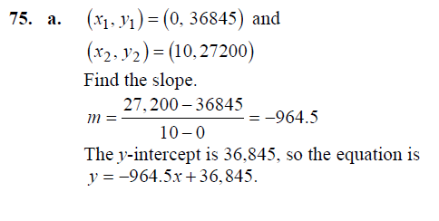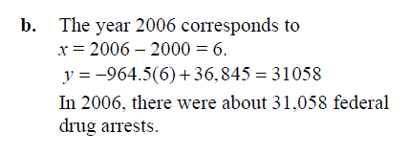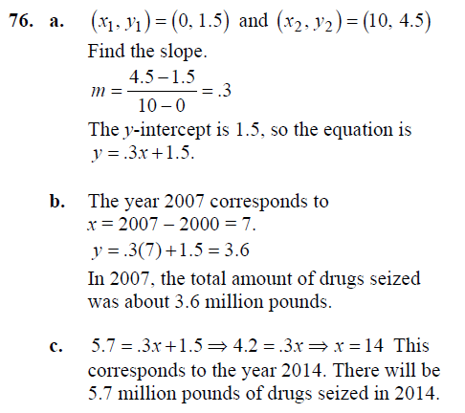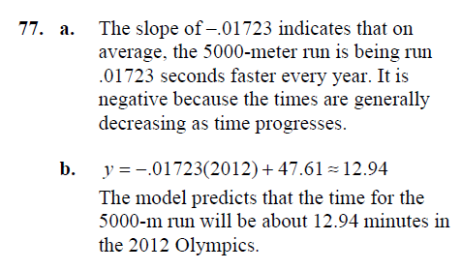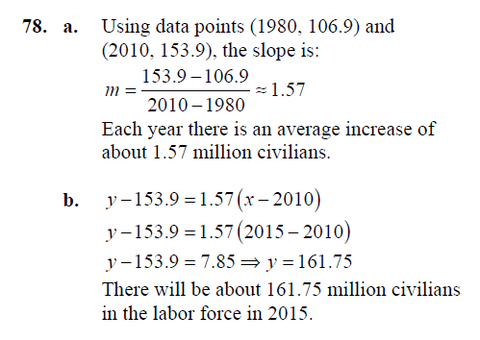
79.
a)Since x represents the number of years after 2000, the linear equation is requested, we have the points: ﻿(x1​,y1​)﻿ =(10,3500) and ﻿(x2​,y2​)﻿ = (15,5000)
the linear equation can be calculated as:
﻿y−y1​=m​​(x−x1​)﻿
m=(y2-y1)/(x2-x1)=>(5000-3500)/(15-10)=300
putting the given values, we have
﻿﻿y−3500=300(x−10)﻿
﻿﻿y−3500=300x−3000﻿
﻿y=300x−3000+3500﻿
﻿y=300x+500﻿
b)The average annual cost in 2014, we can calculate it with x = 14
﻿y=300x+500﻿
﻿y=300(14)+500﻿
y﻿=4200+500=4700﻿
the average annual cost in 2014 is 5500
c)We compute x for y> 6000
﻿300x+500 = 6000
x = (6000-500)/300
﻿x=18.33 x=19
for the year 2019 exceeds $ 6000
80)
a)We have the points: ﻿(x1​,y1​)﻿ =(10,1000) and ﻿(x2​,y2​)﻿ = (15,12000)
the linear equation can be calculated as:
﻿y−y1​=m​​(x−x1​)﻿
m =(12000-10000)/(15-10)=400
putting the given values, we have
﻿y−10000=400​(x−10)﻿
﻿﻿y=400x−4000+10000﻿
﻿y=400x+6000﻿
b)The average annual cost in 2012, we can calculate it with x = 12
﻿y=400x+6000﻿
﻿y=400(12)+6000﻿
y﻿=10800
the average annual cost in 2012 is 10800
c)We compute x for y> 25000
﻿400x+6000﻿ =25000
﻿x =(25000-6000)/400
x =47.5 x = 48 ﻿
for the year 2048 exceeds $ 25000

